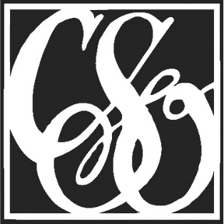
Cheyenne Symphony Orchestra

Finance Committee Meeting Schedule, 2015-2016 Season
Month Meeting Date / Time
September Thursday, September 10, 2015, 5:00 p.m. at the CSO office
October Thursday, October 8, 2015, 5:00 p.m. at the CSO office
November Thursday, November 12, 2015, 5:00 p.m. at the CSO office
December Thursday, December 10, 2015, 5:00 p.m. at the CSO office
January Thursday, January 14, 2016, 5:00 p.m. at the CSO office
February Thursday, February 11, 2016, 5:00 p.m. at the CSO office
March Thursday, March 10, 2016, 5:00 p.m. at the CSO office
April Thursday, April 14, 2016, 5:00 p.m. at the CSO office
May Thursday, May 12, 2016, 5:00 p.m. at the CSO office
June Thursday, June 9, 2016, 5:00 p.m. at the CSO office

